GRANA
A new full length album of mandolin and violin duets from
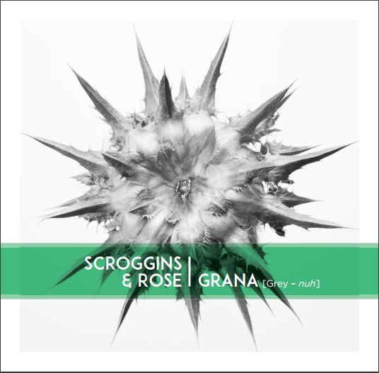
Scroggins & Rose
San Francisco, CA - Award winning instrumentalists and composers Tristan Scroggins and Alisa Rose have announced that the release of their debut album entitled GRANA will come this May. The duo, going by the name Scroggins & Rose, have already received praise for their work from top musicians in their field including Grammy award winner John Reischman who says "Alisa Rose and Tristan Scroggins have released a wonderful recording. Great tunes played beautifully, and with feeling. Hard to believe all this music comes from just two people!" The album features 14 tracks of live acoustic mandolin and violin duets with six original tunes and seven improvisations.
The idea for a largely improvisational album came after the two met while teaching at a bluegrass camp in British Columbia. Alisa, a grammy nominee with roots in both classical and american traditional music, and Tristan, a second generation bluegrass musician recently nominated for the International Bluegrass Music Association's Instrumental Momentum Award, found that they were quickly able to blend their unique styles into intriguing, musically rich atmospheres. Together, both live and on this recording, they explore the potential of the acoustic duet within the framework of classical and folk improvisation.
The album will be released on May 23rd at the end of a week long West coast tour. Anticipation for the album grows with write ups expected in various instrumental publications and a single to be released by the Bluegrass Situation early in May.

Bio: Alisa Rose and Tristan Scroggins combine bluegrass and baroque style improvisation to add to the growing lexicon of new acoustic music. With breathtaking technical virtuosity and knowledge of both traditional folk music and classical styles they create music on the spot utilizing risky improvisation and innovative musical techniques. Their concerts present a study of both active listening and performance skills as they nearly psychically respond to each others spur of the moment musical colors and ideas to create a ever changing exciting performance.

For press inquiries contact: Learn more at:
Tristan Scroggins Alisa Rose Bit.ly/granarecord
tristanscroggins@gmail arosefiddle@gmail.com scrogginsandrose.com
5057202482 4156768596

